  Points of Promise:  Classroom Observation Checklist  identifygifted.education.uconn.edu |  | 1 | 2 | 3 | 4 | 5 | 6 | 7 | 8 | 9 | 10 | 11 | 12 | 13 | 14 | 15 | 16 | 17 | 18 | 19 | 20 | 21 | 22 | 23 | 24 | 25
 | 1. Is motivated and persists in solving difficult math problems. | ☐ | ☐ | ☐ | ☐ | ☐ | ☐ | ☐ | ☐ | ☐ | ☐ | ☐ | ☐ | ☐ | ☐ | ☐ | ☐ | ☐ | ☐ | ☐ | ☐ | ☐ | ☐ | ☐ | ☐ | ☐
 | 2. Learns new concepts in mathematics quickly by making connections. | ☐ | ☐ | ☐ | ☐ | ☐ | ☐ | ☐ | ☐ | ☐ | ☐ | ☐ | ☐ | ☐ | ☐ | ☐ | ☐ | ☐ | ☐ | ☐ | ☐ | ☐ | ☐ | ☐ | ☐ | ☐
 | 3. Applies mathematical concepts to real-world situations. | ☐ | ☐ | ☐ | ☐ | ☐ | ☐ | ☐ | ☐ | ☐ | ☐ | ☐ | ☐ | ☐ | ☐ | ☐ | ☐ | ☐ | ☐ | ☐ | ☐ | ☐ | ☐ | ☐ | ☐ | ☐
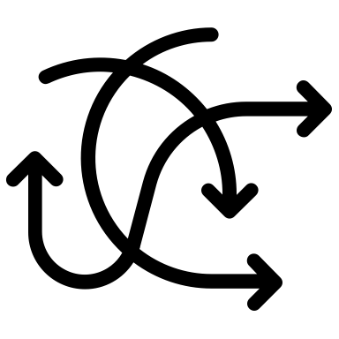 | 4. Shows flexibility in using a variety of thinking or problem-solving strategies. | ☐ | ☐ | ☐ | ☐ | ☐ | ☐ | ☐ | ☐ | ☐ | ☐ | ☐ | ☐ | ☐ | ☐ | ☐ | ☐ | ☐ | ☐ | ☐ | ☐ | ☐ | ☐ | ☐ | ☐ | ☐
 | 5. Demonstrates original ways of approaching math problems. | ☐ | ☐ | ☐ | ☐ | ☐ | ☐ | ☐ | ☐ | ☐ | ☐ | ☐ | ☐ | ☐ | ☐ | ☐ | ☐ | ☐ | ☐ | ☐ | ☐ | ☐ | ☐ | ☐ | ☐ | ☐
 | 6. Makes inferences based on logical reasoning. | ☐ | ☐ | ☐ | ☐ | ☐ | ☐ | ☐ | ☐ | ☐ | ☐ | ☐ | ☐ | ☐ | ☐ | ☐ | ☐ | ☐ | ☐ | ☐ | ☐ | ☐ | ☐ | ☐ | ☐ | ☐
 | 7. Organizes information in a variety of ways to discover mathematical patterns. | ☐ | ☐ | ☐ | ☐ | ☐ | ☐ | ☐ | ☐ | ☐ | ☐ | ☐ | ☐ | ☐ | ☐ | ☐ | ☐ | ☐ | ☐ | ☐ | ☐ | ☐ | ☐ | ☐ | ☐ | ☐
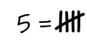 | 8. Demonstrates a strong number sense. | ☐ | ☐ | ☐ | ☐ | ☐ | ☐ | ☐ | ☐ | ☐ | ☐ | ☐ | ☐ | ☐ | ☐ | ☐ | ☐ | ☐ | ☐ | ☐ | ☐ | ☐ | ☐ | ☐ | ☐ | ☐
 | 9. Displays spatial abilities. | ☐ | ☐ | ☐ | ☐ | ☐ | ☐ | ☐ | ☐ | ☐ | ☐ | ☐ | ☐ | ☐ | ☐ | ☐ | ☐ | ☐ | ☐ | ☐ | ☐ | ☐ | ☐ | ☐ | ☐ | ☐
[ –––––––––– patterns ––––––––––– ]
[ – connections – ]
[ –– creativity –– ]
Lesson: As a Rule  Fraction Memory  Is It Worth It?  Keep Your Balance  Measuring Up Date ____________ Time ____________

